

Technology Management

Assignment 4

Section A

Zaid Mustafa

22-10249

Waqas Rasheed

22-11004

Hatib Zubair

241547206

HR Service Management 3

Request 1: Employee Onboarding 4

Request 2: Employee Offboarding 4

Request 3: Change in Request 5

PROJECT ‘PRO TECH’ 7

SCRUM Project 7

Issue 1 8

Issue 2 8

Issue 3 9

# HR Service Management

We created a project for HR service management, where we would request 3 services from the IT operations team.

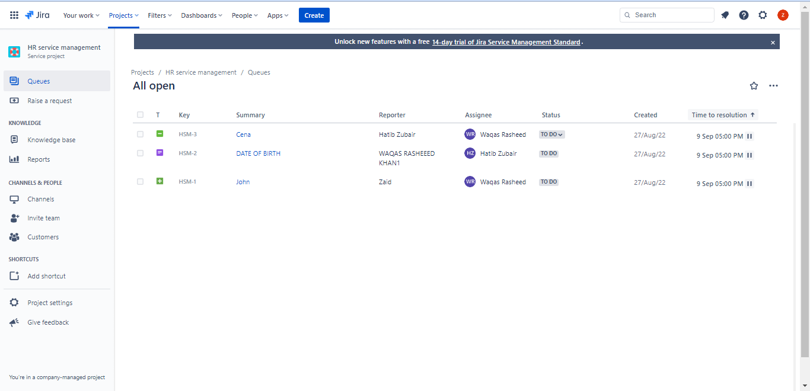

After that we requested 3 different services:

First request was for Employee Onboarding

Request 1: Employee Onboarding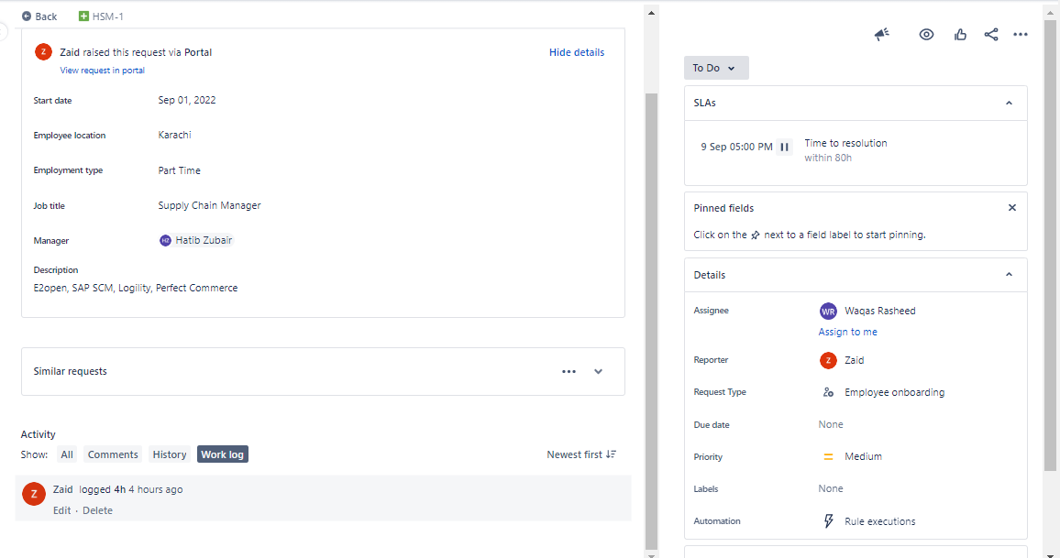

Second request we made was for Employee offboarding

Request 2: Employee Offboarding

Third request we made was for change in one of the recent requests

Request 3: Change in Request

Total of three requests were made, a date was set for them to resolved and request the service to be provided in the given time

# PROJECT ‘PRO TECH’

We created a SCRUM for our Project of 4 weeks.

## SCRUM Project

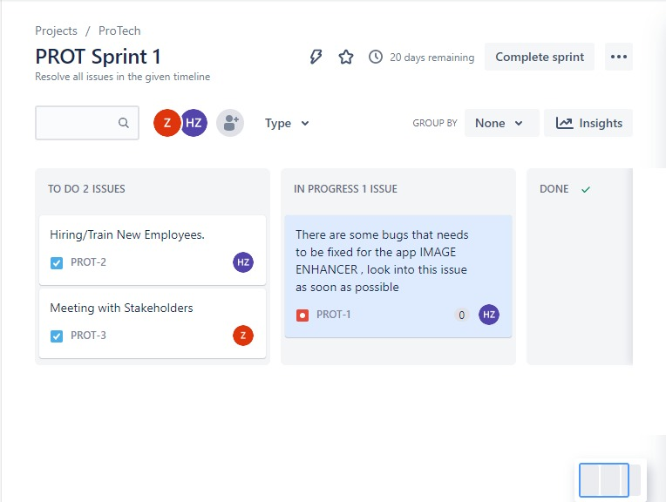

We created 3 issues (showing in backlog) that need to be resolved by the IT Operations Team.

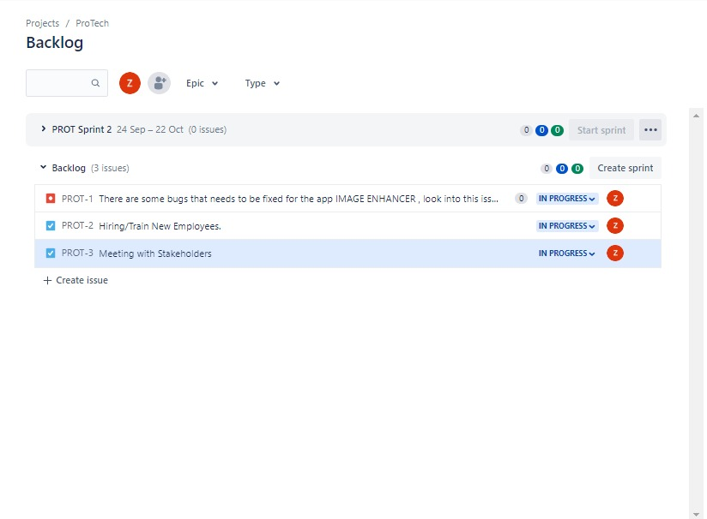

## Issue 1

An issue created was to hold a meeting with stakeholders.

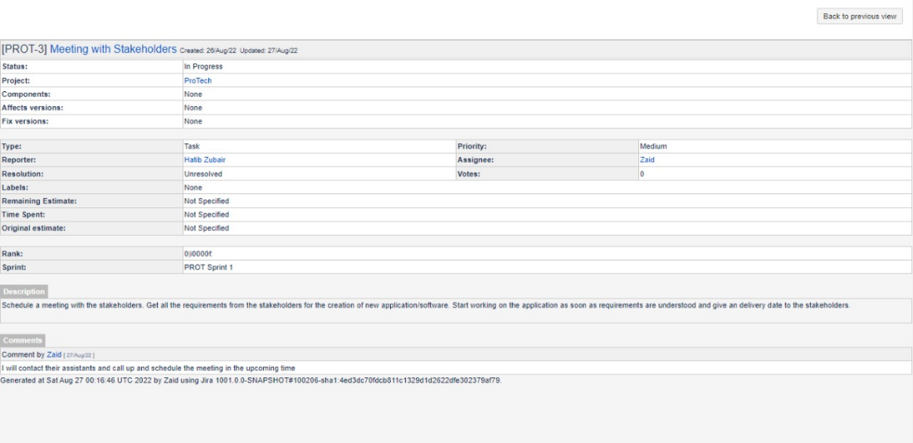

## Issue 2

There was a need for 5 new employees and to get them trained and settled in the office environment.

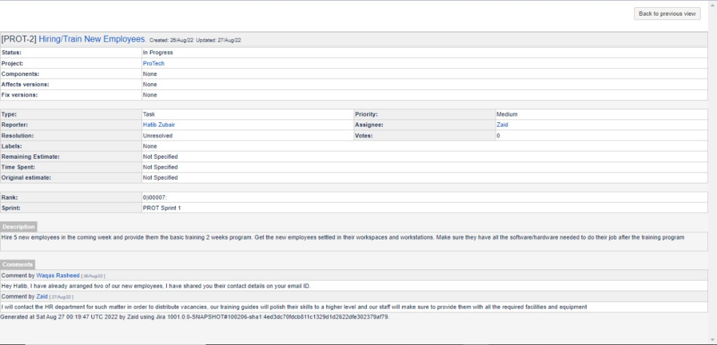

## Issue 3

There are bugs in the application which need to be resolved as soon as possible.



Each individual either Waqas, Zaid or Hatib was a Project Manger in one scenario and a Software Development Team member in the other scenario. We did not stick one role to either the three of us, we kept switching in so that everyone can understand different roles of the team and every one of us can understand every phase of Jira Service Management and Jira Software.